Changes added during refactoring the code:

1. Adding unit test for Content Controller using Moq to create Fake Content repository.

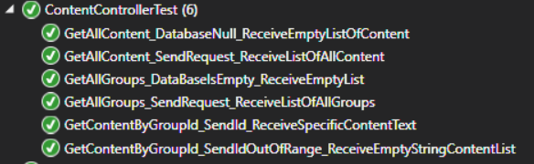

1. Adding unit test for Content Repository using Moq to create Fake DbContext

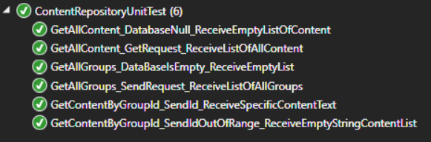

1. Changing AuthHTTP header with header manual to add Bearer to the header of the POST request in Agular.
2. All the requests from content controller are **End point secured** and need authorization

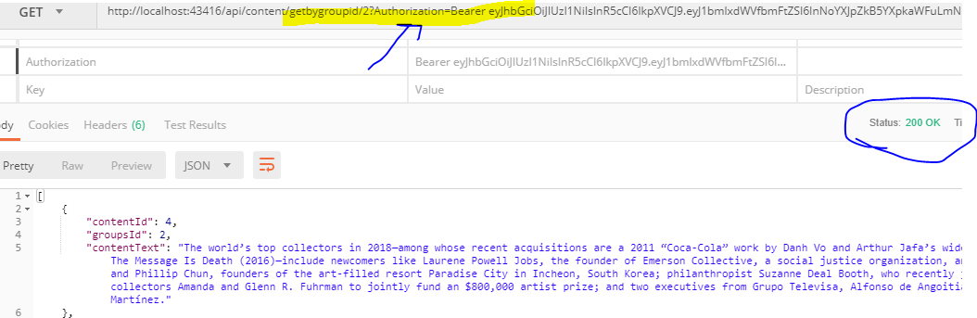

1. If a request has a wrong JWT will get 401 unauthorized error.

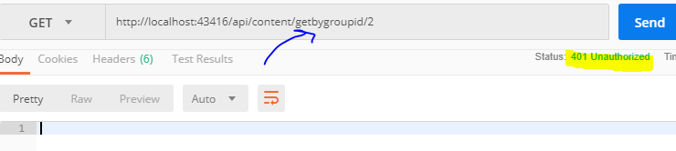

1. The codes have been refactored to IQueryable to make it more consistent.

Nymity Test Project

1. Download clone the file from

https://github.com/syazdian/AngularNews.git

1. For running the Angular file:

I have removed the “node_modules” file but have uploaded a customized bootstrap in another

node_modules which is located in main folder.

So open the file with Visual studio code and

Run npm install 🡪 ng serve

You should see:

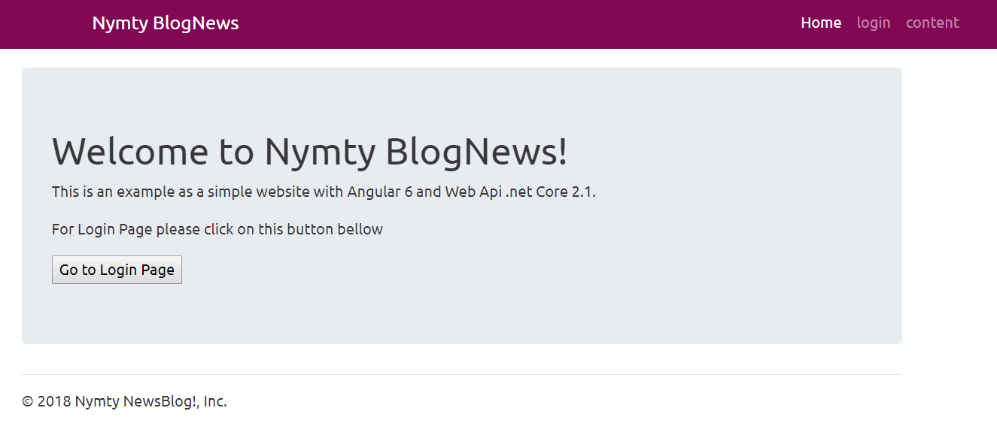

For setting the WebApi :

1. I have used Microsoft Identity .core 2.0 taking advantage of Code First for

So you can create the database with seeds in it :

Add-migration dbInit

Update-database

1. To make it easier I have attached the database script, so simply run it create a database called:

NimityWeb3

1. To be sure it is working properly I have added for Cross-Origin I have added corss origin.

Demo:

The username: sharif@yazdian.ca

Password: 123@Ab

Is

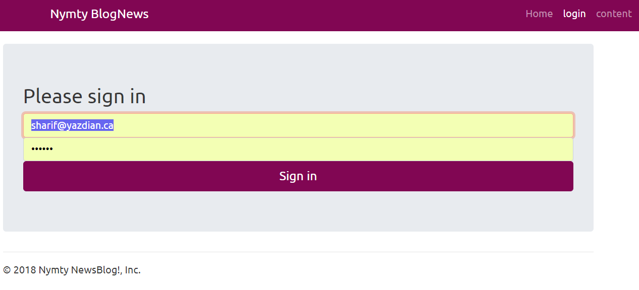

If you click on sing in you’ll see:

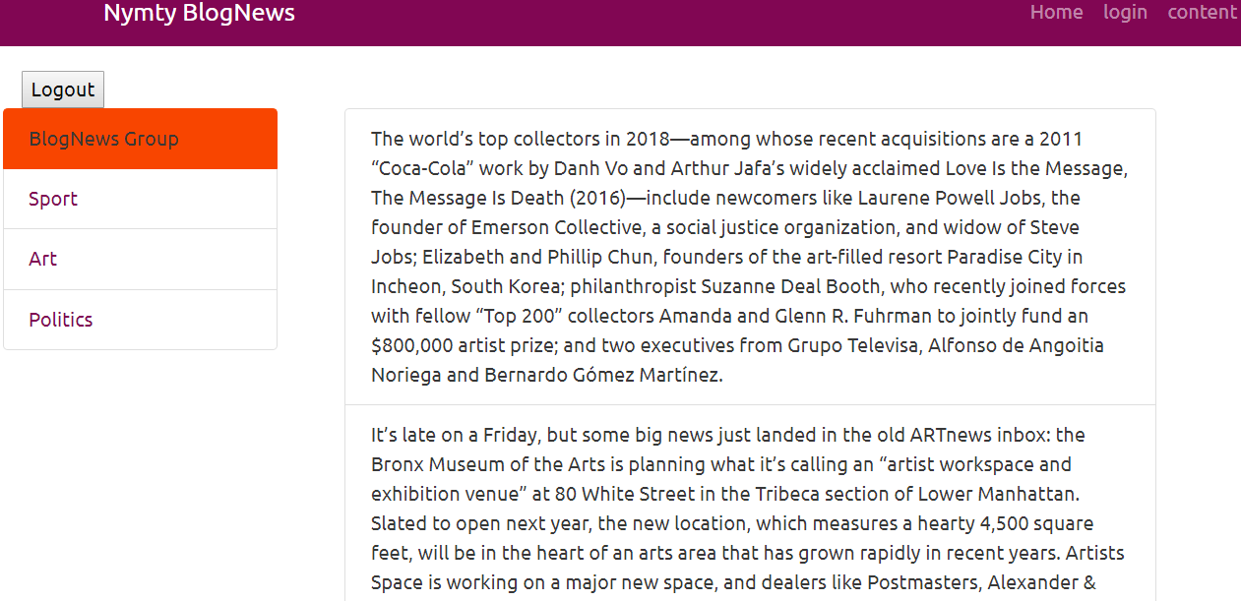

And with clickin on other topics you see other contents:

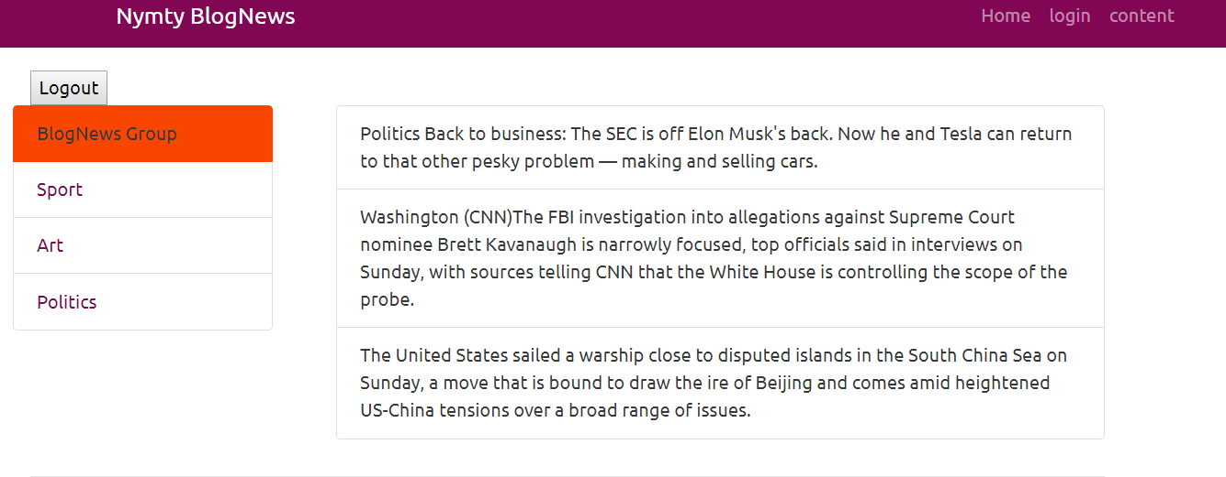

And with clicking on LOGOUT button you’ll go to Login page.

I have used JWT for validation and AuthGuard for this project.